**Experiment 7 Date:** 20/03/2023

**Aim:**

Familiarization of Linux Commands

**Course Outcome(CO2):**

Perform system administration task

**Procedure:**

1. expr :- Evaluate the given expression and display the output.

$expr 12 + 8

Output:

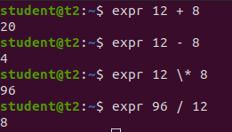

* 1. expr x + y :- Add two variables obtained through read

$read x

$read y

$expr $x + $y

Output:

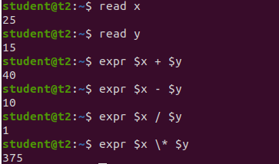

1. df :- Get a report on disk utilization of the system

$df

Output:

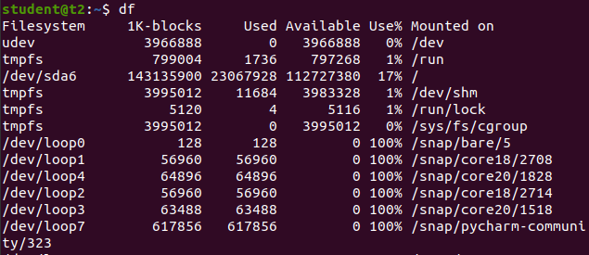

1. du :- check how much space a file or directory in a given directory

$du file.txt

Output:



1. sudo :- superuser do
   1. sudo useradd user :- Add new user

$sudo useradd Sreerag

Output:

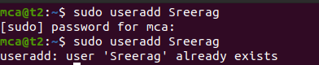

* 1. sudo passwd user :- Update password of the user

$sudo passwd Sreerag

Output:

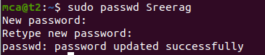

* 1. sudo groupadd -g identifier name:- To create new group

$sudo groupadd -g 269 mcastd

* 1. sudo usermod -G name user :- Add users to group

$sudo usermod -G mcastd Sreerag

* 1. id user :- Details on group name and numeric id of particular user.

$id Sreerag

Output:



1. compgen -g :- Display all the groups created

$compgen -g

Output:

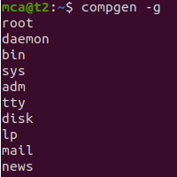

1. chmod :- Used to change the access permissions of files and directories. It stands for change mod namely, read(r), write(w), execute(x)
   1. chmod -wx file :- deny permission to write and execute for file

$chmod -wx file

Output:



* 1. chmod +wrx file :- give permission to write, read and execute for a file

$chmod +wrx file

Output:

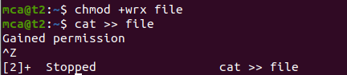

1. sudo chown :- Used to change ownership of a file or directory for a user or a group. It stands for change owner.

$sudo chown Sreerag file

Output:

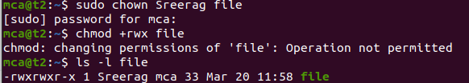

1. sudo userdel user :- Delete user

$sudo userdel Sreerag

Output:

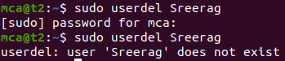

1. sudo groupdel name :- Delete group

$sudo groupdel mcastd

Output



**Result:**

Output displayed successfully and CO2 was obtained.